Golden Triangle with Goa & Mumbai
11 Nights / 12 Days | 1N Delhi - 1N Agra - 2N Jaipur – 2N Delhi - 3N Goa - 2N Mumbai

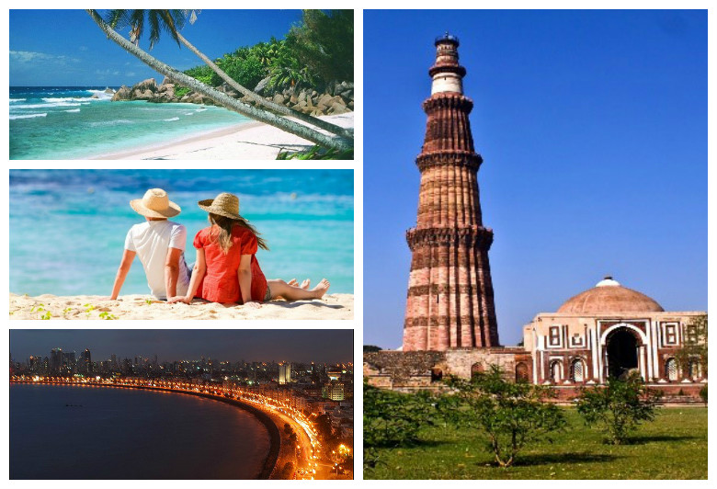
ITINERARY:

Day 01 Arrival in Delhi
Meet our representative upon arrival in Delhi and proceed to your hotel. After reaching, check-in at the hotel and spend rest of the evening at leisure. Overnight stay in Delhi.

Day 02 Delhi - Agra (210 kms / approx. 4 hours)
On arrival in Agra, check-in into your Hotel. Later proceed for Half Day City Tour of Agra. Visit the Red Fort, which was commissioned in 1565 by Akbar. The beautiful yet forbidding structure is a handsome example of Mughal architecture. Later, visit the Taj Mahal … a mausoleum built as a symbol of Emperor Shah Jahan’s devotion to his beloved queen Mumtaz Mahal. Considered an architectural marvel, its construction took thousands of workers over 21 years to complete. Overnight in Agra.

Day 03 Agra – Jaipur (230 km/approx. 5 hours)
After breakfast, drive to Jaipur and enroute visit Fatehpur Sikri, which was built by Emperor Akbar and is home to many historical buildings. Akbar wanted to make Fatehpur Sikri his headquarters; however, he had to abandon it due to shortage of water. The Tomb of Sheikh Salim Chishti enshrines the burial place of the Sufi saint who lived a religious life here. Today, Fatehpur Sikri is a UNESCO World heritage site. Further drive to Jaipur and check into your Hotel. Jaipur is the gateway to the magnificent and vibrant state of Rajasthan. Evening take a stroll in the markets of Jaipur for the traditional dresses and shoes, curio shops, blue pottery etc. Overnight in Jaipur.

Day 04 Jaipur
Proceed for full-day sightseeing trip of Jaipur, also known as the ‘Pink City’. The city of Jaipur is capital to the state of Rajasthan, famous for its colorful culture, forts, palaces, and lakes. Jaipur owes its name to the founder of the city, warrior king Sawai Jai Singh II. Visit the Amber Fort. The best way to explore the fort is to ride up to it on Elephant back. Prominent structures inside the fort are the Diwan-i-Aam, adorned with latticed galleries, the Ganesh Pol, with a beautiful painted image of Lord Ganesh, and the stunning Sheesh Mahal, a hall decorated with thousands of tiny mirrors. Later, stop to photograph the beautiful Hawa Mahal, also known as the “Palace of the Winds.” This beautiful façade with its ornately carved latticework windows was designed so the ladies of the palace could look out onto the streets unobserved. Later you will visit the City Palace… again, a synthesis of Rajasthani and Mughal styles. The museums here showcase rare and ancient manuscripts, arms dating back to the 15th century, and costumes of erstwhile royalty. Later, visit the Jantar Mantar Observatory, comprising geometric devices for measuring time, and tracking stars in their orbits. Overnight in Jaipur.

Day 05 Jaipur – Delhi (250 km/approx. 5 hours)
After breakfast, drive to Delhi and check-in at hotel. Spend rest of the day at leisure. Alternatively you may go for shopping in evening. Overnight stay in Delhi

Day 06 Sightseeing in Delhi
After breakfast, proceed for a full-day tour of Old and New Delhi. This fascinating city has been in existence since the 6th century BC and has seen ups and downs from the rule of the Pandavas right up to the British Raj. Visit Jama Masjid, which is the largest mosque in India, commissioned by Emperor Shah Jahan. The courtyard of the mosque can hold about 25,000 worshippers. Enjoy a rickshaw ride in Chandni Chowk, the busiest market in Old Delhi…noisy, chaotic and uniquely Indian. You will then drive past to the Red Fort, which was constructed during the rule of Emperor Shah Jahan and served as the residence for the Mughal royal family. It continues to be significant till date, as every Independence Day, the Prime Minister makes a speech from its ramparts as the Indian flag is hoisted. Later, drive past President House and several other government buildings in Edwin Lutyen’s Delhi before you head toward Rajghat, the memorial to Mahatma Gandhi. This simple memorial marks the spot where Mahatma Gandhi was cremated in 1948. Thereafter, visit Humayun’s Tomb, commissioned by Humayun’s wife Hamida Banu Begum in 1562. It was the first garden tomb built in the Indian sub-continent where the Persian architect used red sandstone on a large scale. Later in the evening visit the Qutab Minar, which is the tallest brick minaret in the world; it was commissioned by Qutbuddin Aibak, the first Muslim ruler of Delhi. Overnight in Delhi.

Day 07 Delhi - Goa
After breakfast, proceed to the airport to board the flight to Goa. Here, you will be assisted by our representative and transferred to your designated hotel for check-in. Spend rest of the day at leisure and overnight stay in hotel.

Day 08 & 09 Day at Leisure in Goa
After breakfast, enjoy full day at leisure in Goa. Alternatively, you may plan independent activities to explore the city. Overnight stay at the hotel.

Day 10 Mumbai Sightseeing
After breakfast, proceed to airport to board flight to Mumbai and drive to check-in at hotel. Later, at noon, enjoy half day city tour covering Gateway of India, Victoria Terminus, Prince of Wales museum, Juhu beach and Chowpatty. Return to hotel for overnight stay.

Day 11 Day at Leisure in Mumbai
After breakfast, spend full day at leisure. Alternatively, you may proceed for an optional tour to explore Elephanta Caves (UNESCO world heritage site) - the rock-cut artwork represents some of the most impressive temple carving in all of India. The main Shiva-dedicated temple is an intriguing latticework of courtyards, halls, pillars and shrines, with the magnum opus a 6m-tall statue of Sadhashiva – depicting a three-faced Shiva as the destroyer, creator and preserver of the universe. Overnight stay in Mumbai.

Day 12 Departure from Mumbai
After breakfast, you will be transferred to Mumbai airport for return flight back home.

PACKAGE INCLUSIONS:
• 11 night accommodation in well-appointed rooms as mentioned below hotels or equivalent
• Assistance at the airport & Hotel check-in / check-out
• Services of English-speaking guide during sightseeing tours except GOA
• Entry Fee at the Monuments
• Sightseeing as per itinerary by private tourist vehicle
• Rickshaw ride in Chandni Chowk
• Elephant / Jeep ride at Amber Fort
• Drivers allowances, toll taxes and Govt. Service Tax

NOTE:
MONUMENTS CLOSED ON
Agra - Taj Mahal on every Friday
Jaipur – Elephant ride at Amber Fort will not be operational during Eid /Navrataras Festivals
Mumbai - Prince of Wales Museum will be closed on Monday
Hotel Check in 1400hrs and check out 1200hrs

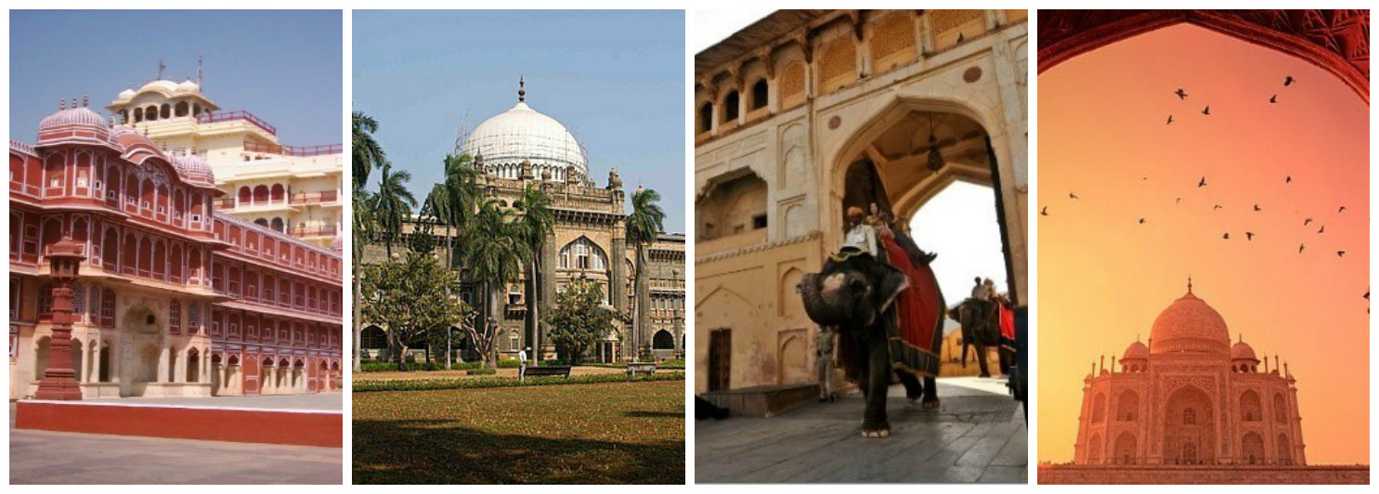
Highlights:
- Visit in Delhi – Jama Masjid, Qutub Minar, Humayun Tomb
- Drive past in Delhi - Red Fort, Rajghat, President House & India Gate
- Rickshaw ride in Chandni Chowk
- Visit in Agra – Taj Mahal, Agra Fort & Fatehpur Sikri
- Visit in Jaipur – Amber Fort, City Palace & Hawa Mahal
- Elephant ride at Amber
- Explore Beaches and nightlife of Goa
- City Tour in Mumbai, Optional – Tour of Elephanta Caves
- Services of English-speaking guide during sightseeing tours
- Assistance at airport and sightseeing tours by private air-conditioned vehicle
- Start From Delhi and End in Mumbai

